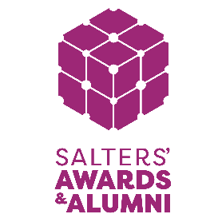
CHEMISTRY CHANGEMAKERS AWARD APPLICATION FORM

The Salters' Institute believes that chemistry can change our world for the better.
Up to 6 awards, each of £150 will be given to students aged 16-17 who excel in:
- Identifying a societal issue to tackle, and explaining the importance of resolving this issue
- Designing a creative, original and relevant chemistry related solution
To enter you will need to design an A3 poster that includes the following information:
- A brief description of the societal issue
- Why is it an issue and who it affects
- Your chemistry related solution/invention and how it will help
- Challenges faced when resolving this issue
Your poster can be created digitally or on paper and will need to be sent from your school email to awards@saltersinstitute.org, alongside this form. If designed on paper you will need to send a photo of your poster ensuring all content is clearly presented.
Please submit both your poster and application form to this Dropbox link (https://www.dropbox.com/request/c5CscPEkAEJUUKc8UijQ) ensuring that uploads are clearly labelled 1. Student’s full name_ poster and 2. Student’s full name_application form.
The deadline for applications is Friday, 20 January 2023. Shortlisted candidates will be invited to Hall on Monday 20 February 2023.
Student’s details

Full name:
Pronouns:
Year group:
Date of Birth:

School Details

Name of school/college:
School/college postcode:

Teacher contact details

Title:
Full name:
Pronouns:
Email:
Phone:

STUDENT’S SUPPORTING QUESTIONS
Please complete the following questions to support your application. Each question has a maximum of 200 words.
- What is your issue?

- Why have you identified this as an issue?

- Who is affected by this issue?

- Why do you want to tackle this issue?

- What is the chemistry part of your solution?

- Who supported you to create your poster (school teacher, friends, parent/carer, a relative, the school librarian)?

- How would you spend your prize money of £150.00 if you were to win? (There is no right or wrong answer!)

