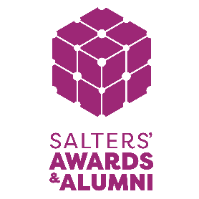
TECHNICIAN AWARDS SUPPORTING STATEMENT: PART B

The Technician Awards aim to recognise and celebrate individuals or teams who have a significant impact on their students and schools, supporting learners to achieve their very best and promoting excellence.

The Awards are an important part of the Institute’s programme of activities and support its mission to promote the practical applications of chemistry at all levels. Award winners will be invited to join the Salters’ Alumni Network and participate in the Institute’s educational outreach, activities and events alongside previous winners.

Up to 3 Awards, each of £1,750* will be made to candidates who are:
- currently working as science technicians in schools and colleges catering for students up to the age of 18 across the UK,
- demonstrate examples of going above and beyond for their students,
- recognise ways to improve their department and/or team for the benefit of their students,
- understand the challenges and opportunities facing their sector and a vision of how they can contribute.
*£1,250 for the technician or team and £500 for their science department

Please send your supporting statement to awards@saltersinstitute.org by 1pm on Wednesday 23rd September 2026. Thank you to Referees for taking the time to complete this supporting statement.

REFEREE’S SUPPORTING STATEMENT
This could be written by a science teacher who works with you, Head of Science or a member of the Senior Leadership Team.
Technician’s (or team’s) full name(s):
Technician’s email (lead technician for team applications):
Referee’s full name:
Referee’s preferred pronouns:
Job title:
School address:
Email:
Phone:

You are asked to write about your school science technician or technician team.

Why do you feel this individual or team are deserving of winning a Salters’ Institute Technician Award? How do you feel that they have demonstrated an outstanding contribution both to the school and their students?

We strongly encourage contributions to this statement from those impacted by the work of the nominee – this could be anonymised quotes from students, science teachers, or other colleagues.

(Maximum 600 words)

The applicant’s completed application, including this supporting statement, will be shared with the reviewing panel. The panel includes members of the Salters’ Institute team and external reviewers, such as industry experts and previous awardees. Before sharing the application externally, we will remove your and your applicant’s name and contact details. By the applicant submitting their application, you confirm that you consent to us sharing the redacted application with the external panel for the purpose of review.

